**Lab3 Report**

Below screenshot represents the start-domain comand used to start the glassfish server in Local Cloudera.

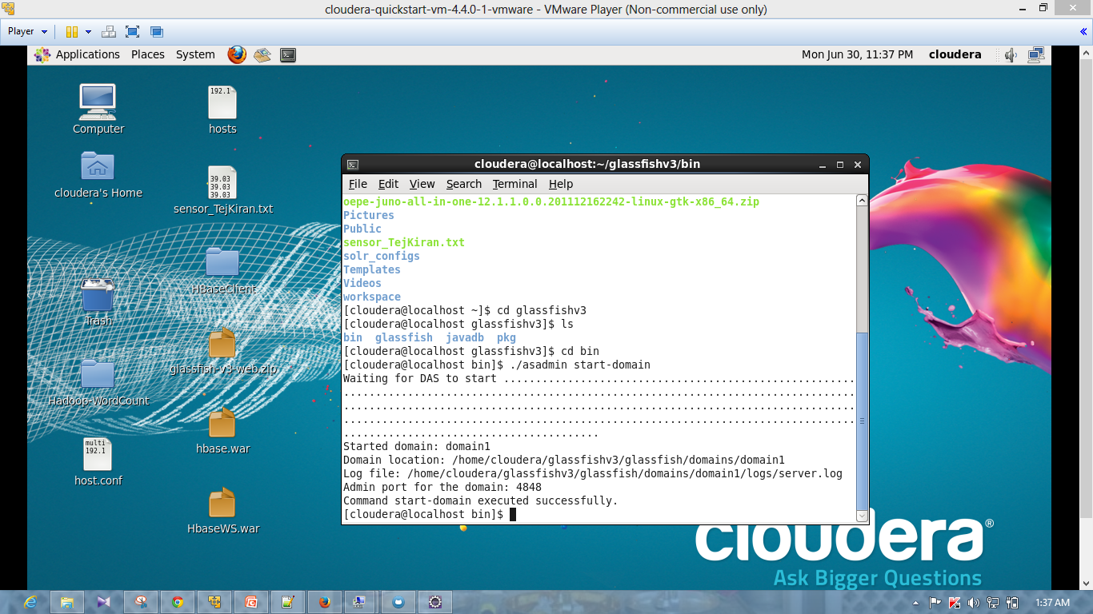

Below sceenshot represents the source code modified according to my datamodel.

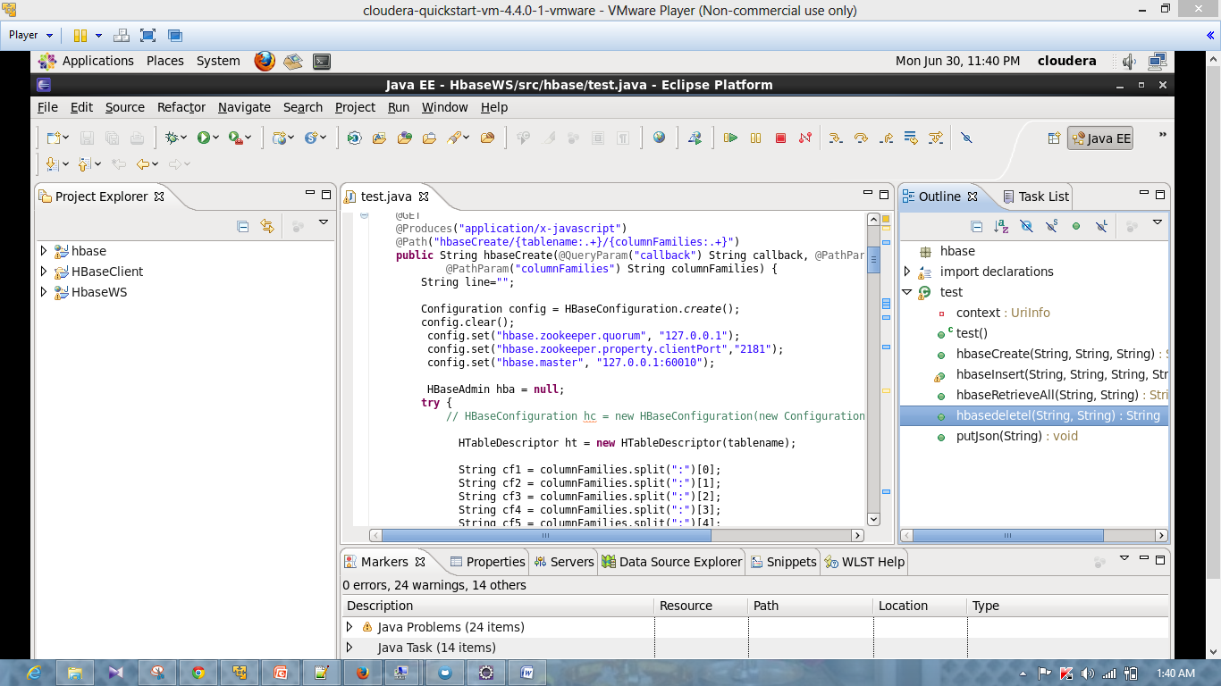

Below Screenshot represents the creation of WAR file in Eclipse.

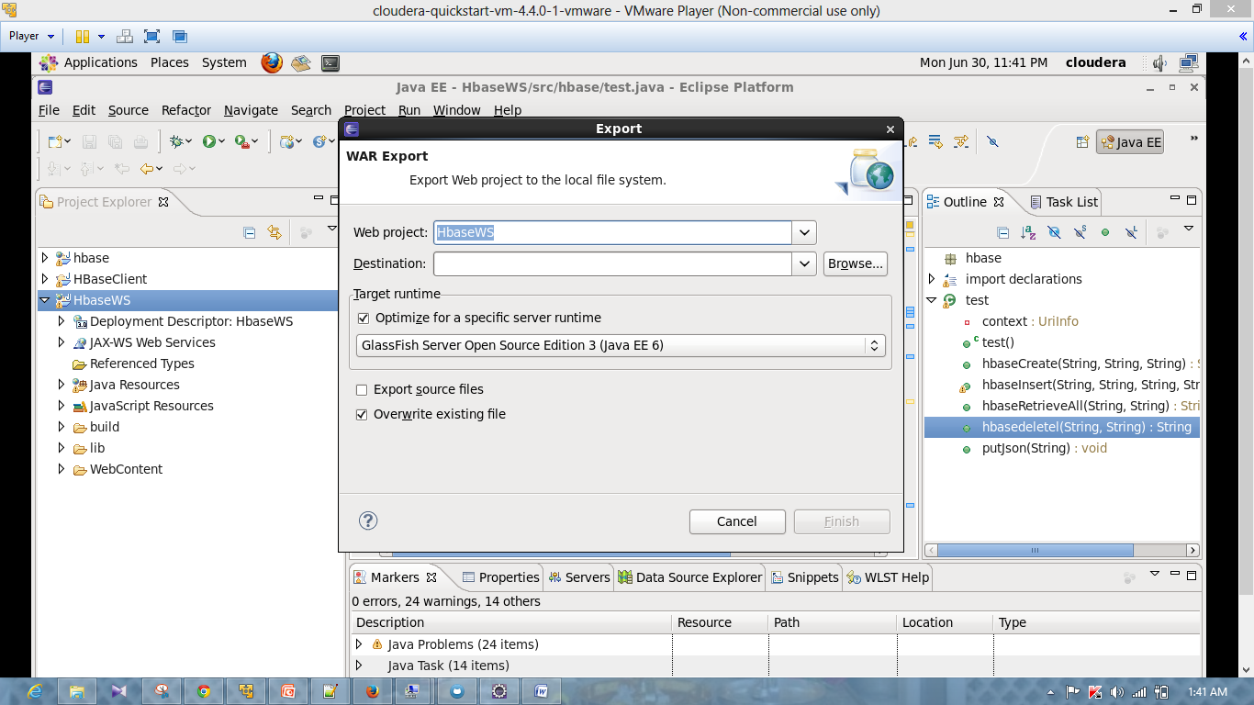

Below Screenshot represents the application pannel in Glassfish server page of local cloudera.

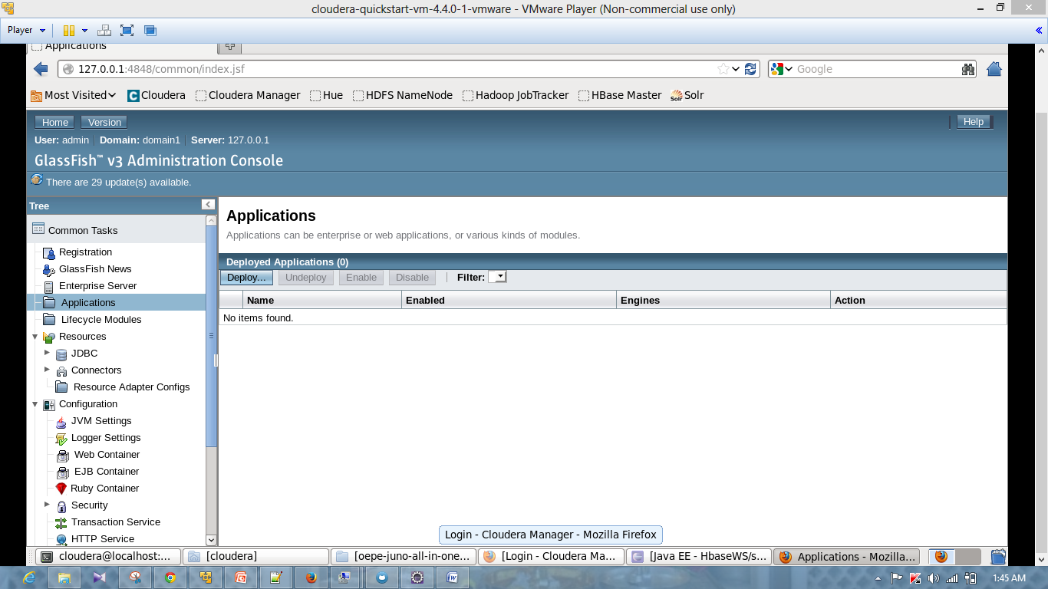

Below screenshot represents the deployment of War file in local cloudera.

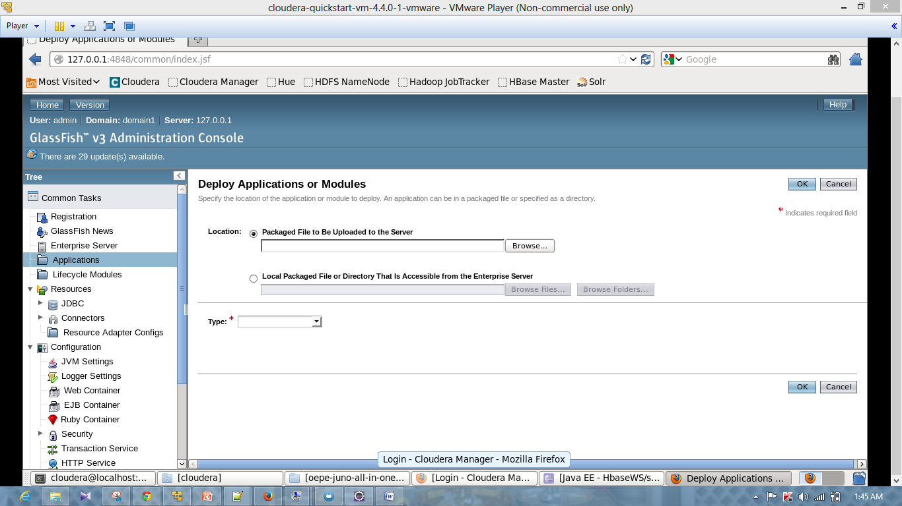

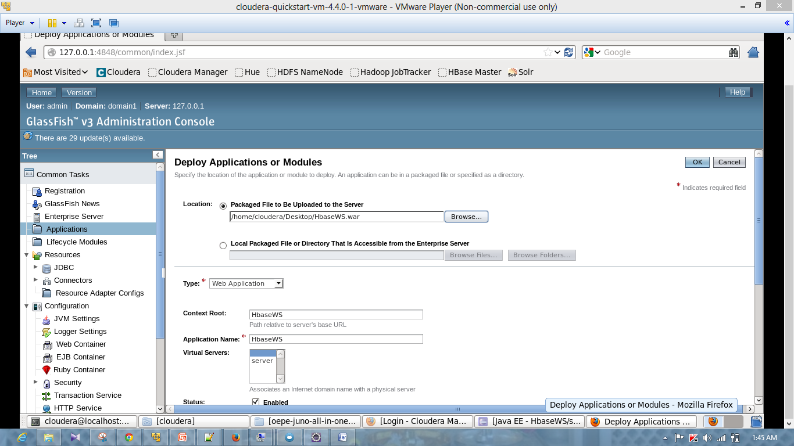

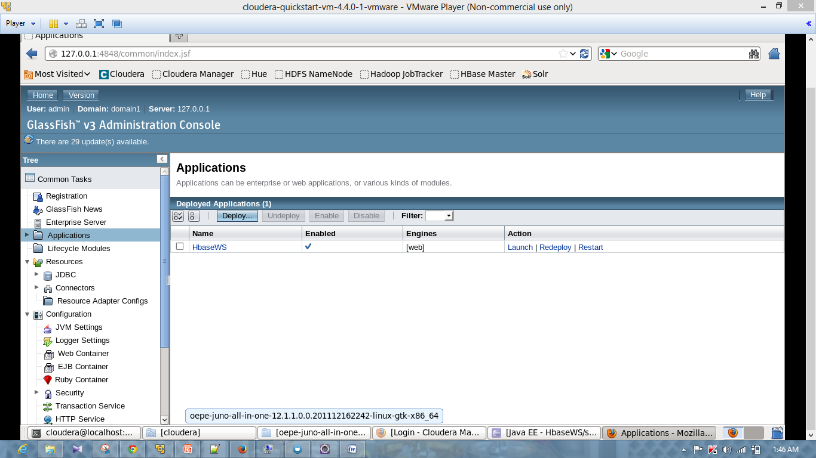

Below screenshot represents the launch of application in server.

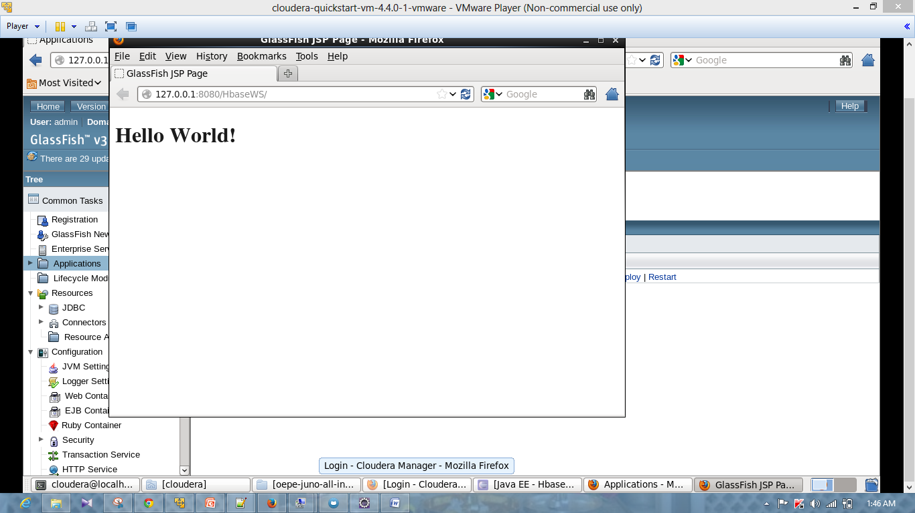

Below screenshot represents the creation of table through URL. I have created Table_Tej1 in this screenshot

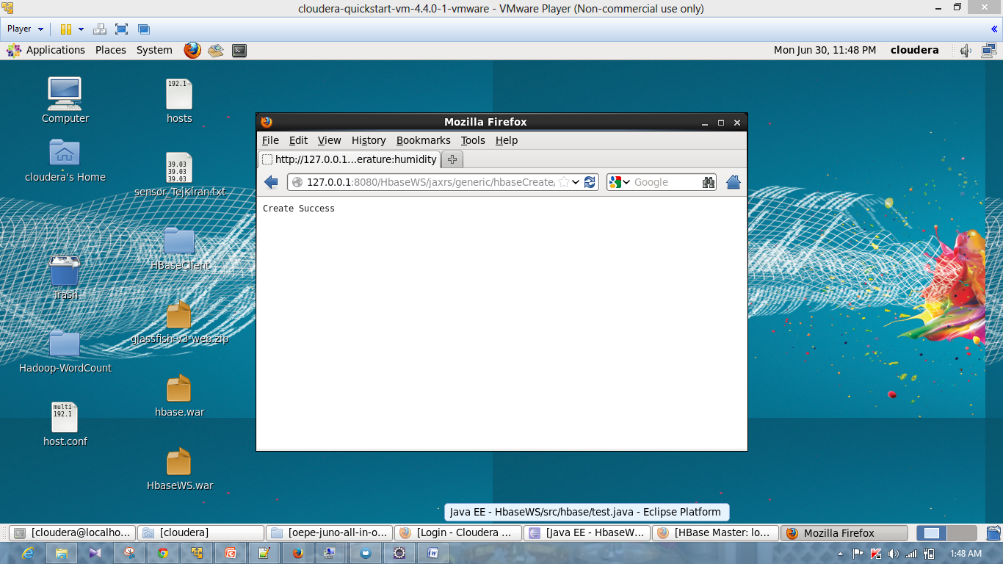

Below screenshot represents the Table_tej1 on HBase Master Page.

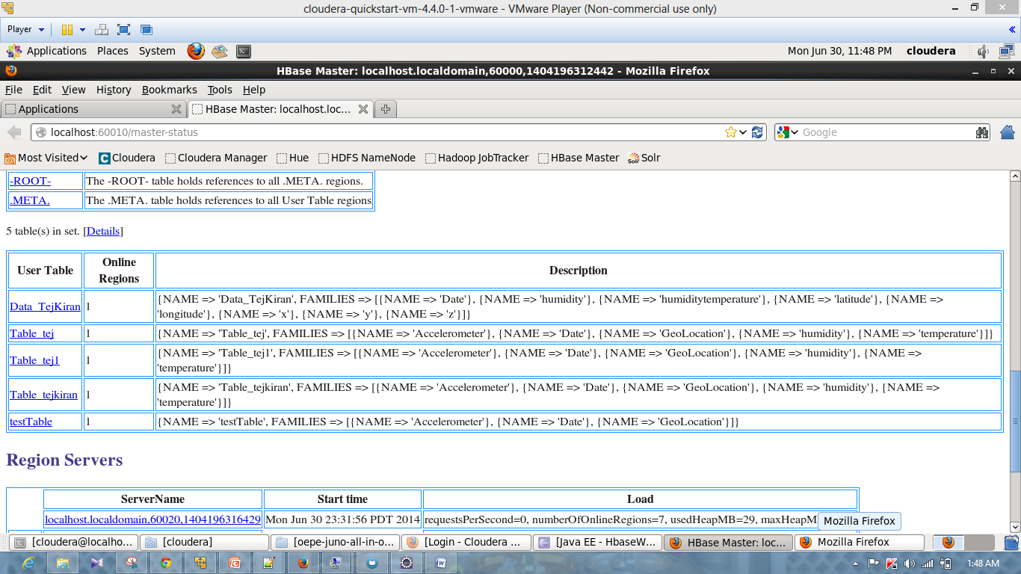

Below Screenshot represents the insertion of data through URL.

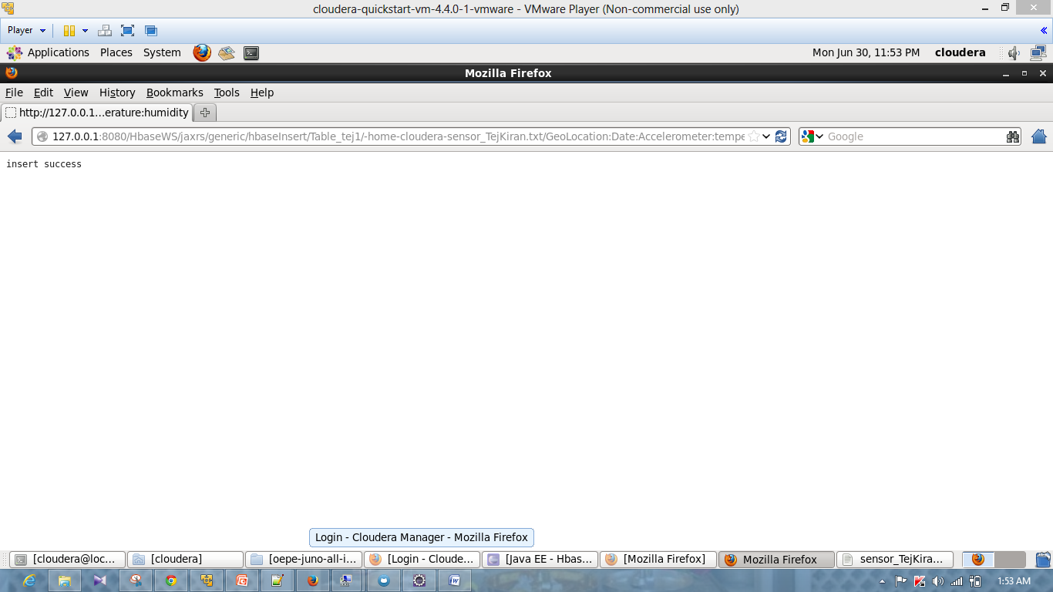

Below Screenshot represents the retrieval of data through URL.

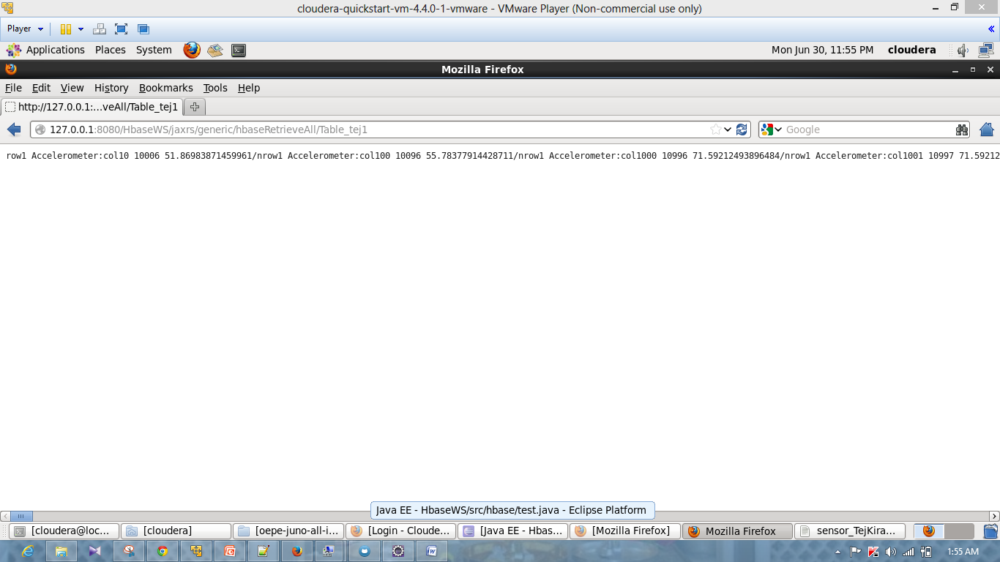

Below Screenshot represents the deletion of data through URL. 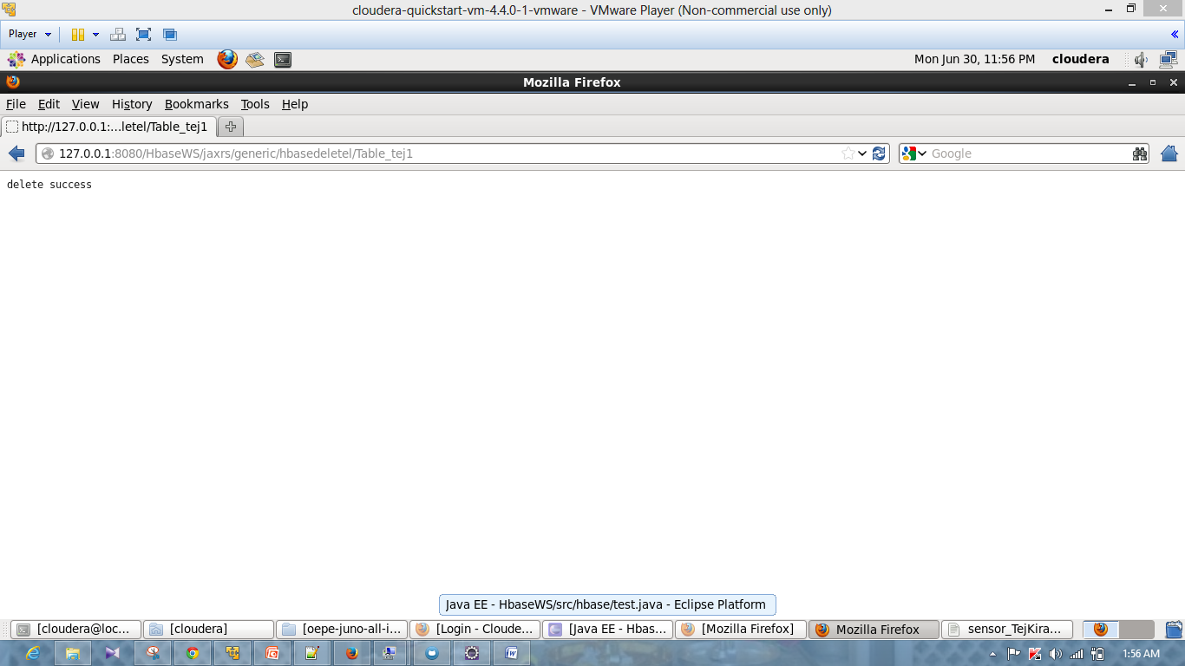

**Android Application:**

Below Screenshot represents the application home page.

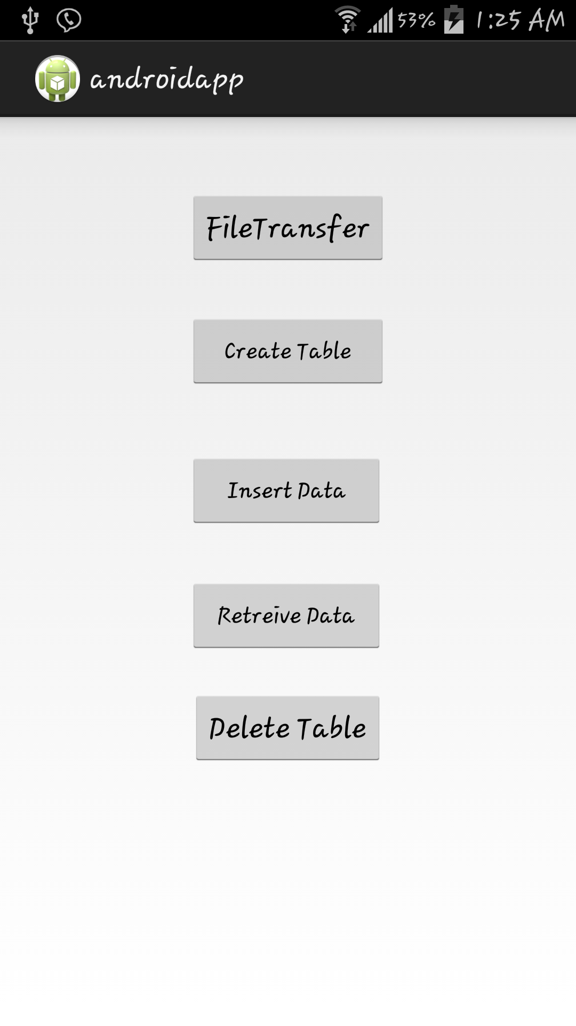

Below Screenshot represents the creation of table through android application.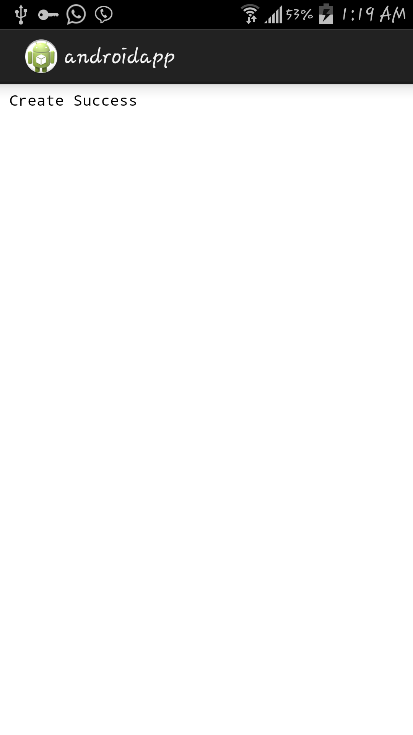

Below Screen shot represents the insertion of data through android application.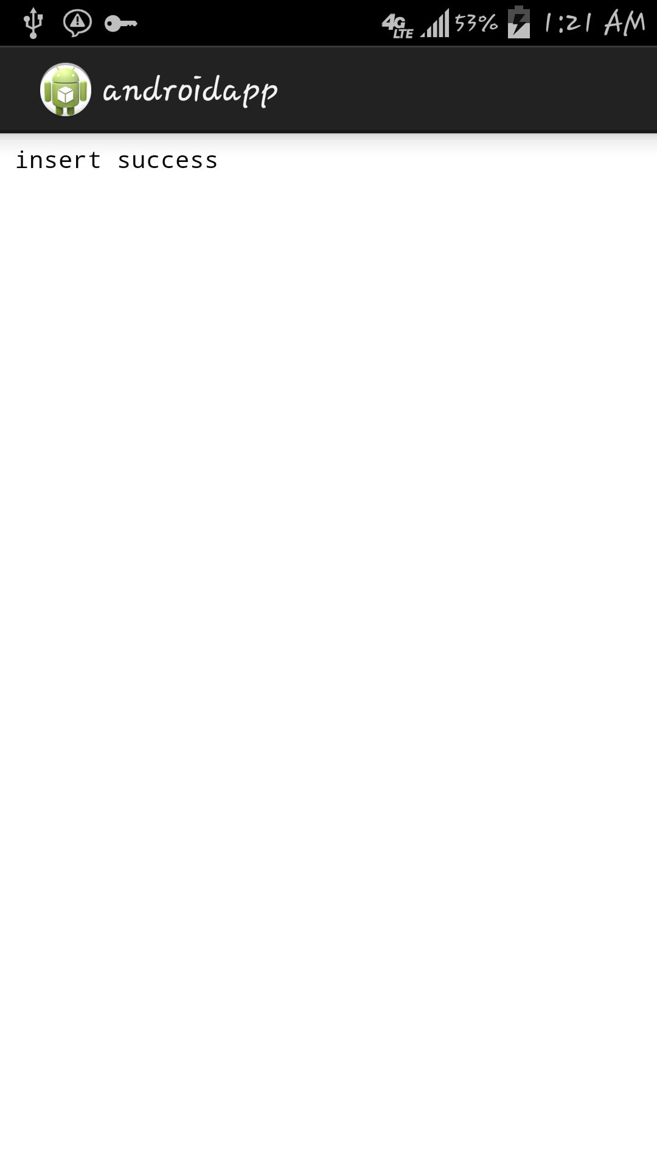

Below Screenshot represents the retrieval of data through android application.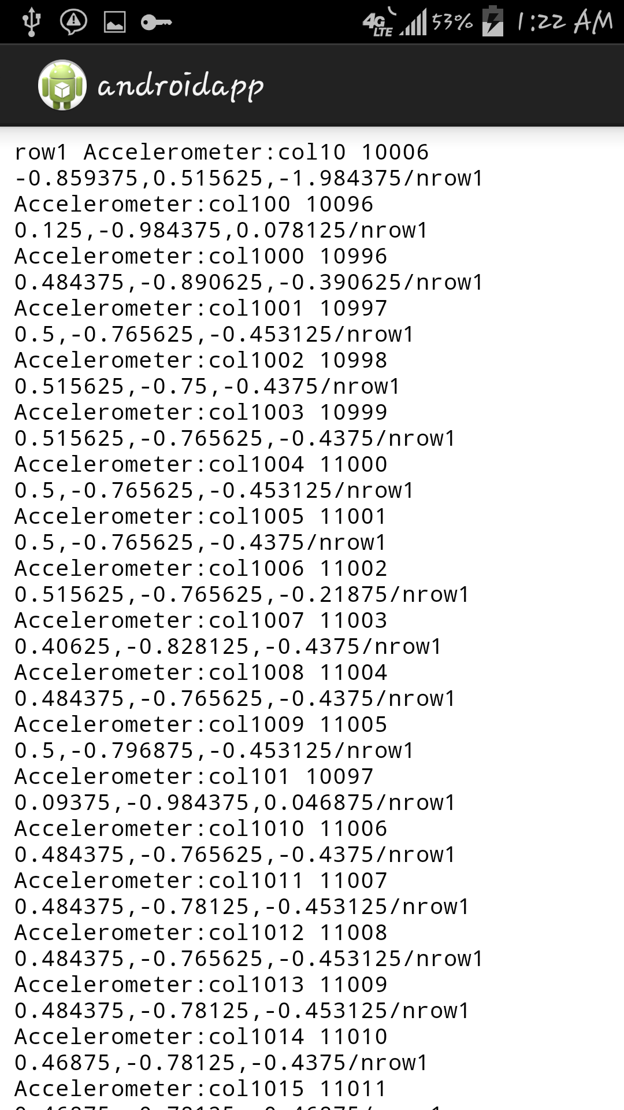

Below screenshot represents the deletion of table through android application.

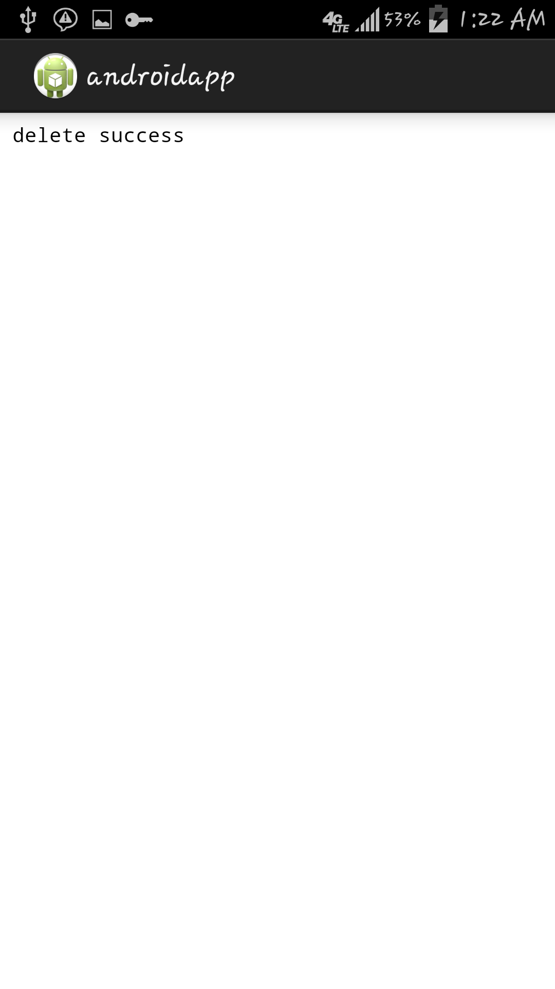

**Issues Faced:**

* I tried to collect data through the same android applicaiton. I was able to start the service in the application but when I use stop service. I was unable to stop service and it runs in background collecting the data.
* While using SSH when I use the code provided in tutorials. My application was crashed .